**Bug ID:** 1

**Bug Summary:** The “addition” function doesn’t work correctly. After clicking calculate button, it reflects wrong digital output in "Result" row

**Environment/URL:** <http://dev-qwallity.herokuapp.com/calculator>

**Operation System:** Windows 64

**Version**: 1

**Browser:** Google Chrome

**Submit Date:** 01/18/2023

**Reporter:** Armine Azaryan

**Steps to Reproduce:**

       1. Open <http://dev-qwallity.herokuapp.com/calculator>

      2. Fill "numer 1" and "number 2" fields

3. Choose "addition" function from "Operations"

4. Press "Calculate" button

**Expected Result:** In "Result" row should be displayed the right digital output

**Actual Result:** In "Result" row is displayed wrong digital output

**Screenshot/video:**

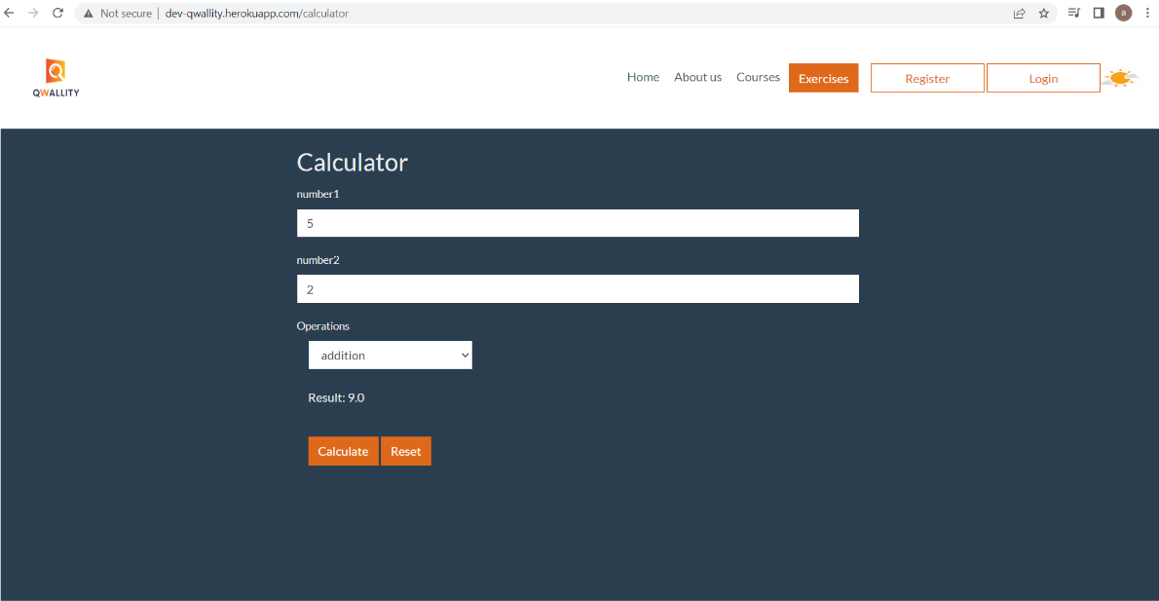

**Notes:** The mentioned function doesn't work correctly for all cases.

The URL was tasted only on Google Chrome browser

**References:** Attached screenshot

**Severity:** Critical